

The University of Azad Jammu and Kashmir,
Muzaffarabad

Name | Kamal Ali Akmal
Course Name | Software Design & Architecture
Submitted to | Engr. Daniyal Nazeer
Semester | 3rd
Session | 2024-2028
Roll No | 2024-SE-38
Lab No | 05
Submission date | 04 December 2025

Part 1: Enrolling in a Course
- Login & Choose: Alice logs into the system and picks a course she wants to take.
- Check & Ask for Permission: The system first checks if the course has open spots. Then, it automatically asks an Admin for approval (to check if Alice has the required previous classes).
- Pay Fees: If the Admin approves, the system sends Alice to a secure Payment Gateway (like PayPal or a credit card processor).
- Confirm & Notify:
  - If payment is successful, the system officially enrolls Alice and sends her a confirmation email.
  - If payment fails, the system tells Alice and cancels the enrollment process.
Part 2: Submitting an Assignment & Getting a Grade
- Upload: Alice finishes her assignment and uploads the file to the system.
- Check the File: The system checks if the file is the correct type (e.g., .pdf) and isn't too large.
  - If the file is invalid, it asks Alice to upload a different one.
- Notify Professor: Once the file is accepted and saved, the system alerts the Professor that a new assignment has been submitted.
- Grade & Feedback: The Professor reviews the assignment, gives it a grade, and writes some feedback. They submit this back into the system.
- Notify Student: The system saves the grade and immediately sends an email to Alice saying, "Your grade is ready!"
Part 3: Handling Problems (Edge Cases)
- Payment Fails: The system tells Alice and doesn't enroll her.
- Wrong File Type: The system immediately warns Alice to upload a correct file.
- Professor is Late: If the professor doesn't grade the assignment after a few days, the system automatically sends them a reminder email.

UML Sequence Diagram for Online University Management System (OCMS)
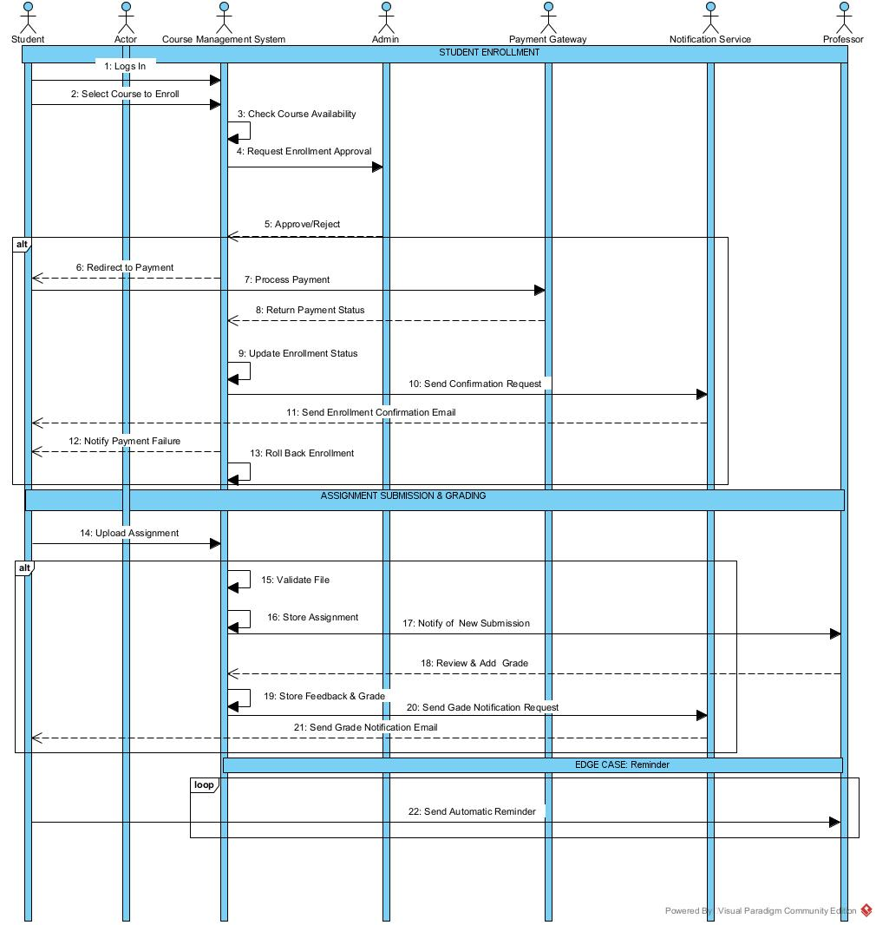

Explanation
- Vertical Lines: Each line represents a different actor or system component (Student, CMS, Professor, etc.).
- Arrows: The arrows represent messages or actions being sent from one component to another.
- Boxes (alt/else): These show "if-then" scenarios. For example, if the payment is successful, then send a confirmation email, else notify of failure.
- Box (loop): This shows a repeating action, like the system sending automatic reminders to the professor.

